 | Web Presence Platform  Strategy & Platform Development

Digital Memebership Card Service API Document

Version 1.2

Revision History
Date | Document Version | Description | Author | API Version
02/11/2014 | 1.0 | Initial version | Susheel Kumar | V1.0
3/27/2014 | 1.1 | Updated response | Susheel Kumar | V1.0
7/01/2014 | 1.2 | Added New API for DMC Email Consent | Ravi Surapur | V 1.2

Contributors
Name | Department

Overview:
The DMC Service Consumer API RESTful web service is a secure service requiring an authentication token. This service API calls the Digital Membership Service service. The service provides the functionality to get member card details. The service relies on a global Vordel policy to check the required HTTP custom headers.

Audience: Consumer
Representation: JSON

Common Reference Information:
For a list of mandatory request headers, as well as a list of standard HTTP error codes, refer to the Common API Reference document.

Vordel Artifacts:

Vordel Polices (Service Specific):
- API10-Digital Membership Card.xml
- API10-Digital Membership Email Consent.xml

XSLT Scripts:

1.

Generic Sequence Diagram for Digital Membership Card API:

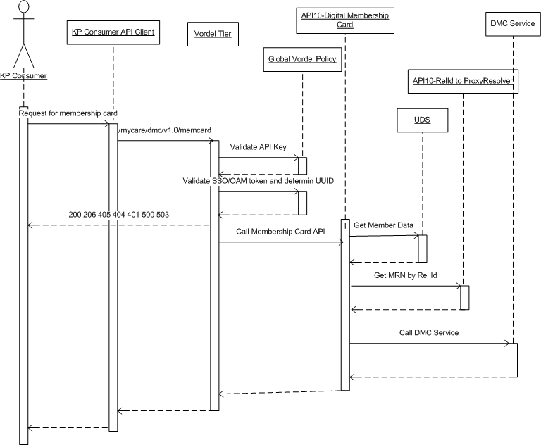
Notes on Message Replies/Threading/Grouping :

1) Digital Membership Card API Request
https://<host>//mycare/dmc/v1.0/memcard

HTTP Method : GET
HTTP Request Headers:
Custom headers | Req. | Description
X-useragentcategory | Y | I = iOS, A = Android, M = mobile web>
X-osversion | Y | Version of the device OS i.e. 5.1
X-useragenttype | Y | Type of agent. Ex iPhone4, Samsung,
X-apiKey* | Y | API Key specific to the consumer, for e.g. kaisermobil93908784817875726966
X-appName | Y | Application name i.e. kp‐mobile_v2.0, KP Mobile
sosession | N | ssosession header received from sign-on service. Required for authorization, Either ssoseesion header or ObSSOCookie is required
X-RELATIONSHIP-ID | N | Comma separated relationship id list, Maximum 10 values allowed
X-correlationid | N | Any unique id for requests, for .e.g. bbbbbbbbbbb121341231
Accept | Y | application/json

Cookies:

Cookie Name | Required | Description
ObSSOCookie | N | Required for authorization, Either ssoseesion header or ObSSOCookie is required

Query Parameters:

Parameter Name | Required | Description
freshness | N | Value in minutes, for example 5
cmsfilter | N | true or false

Request Body:
content-type : application/json
charset: UTF-8

2) Digital Membership Email Consent API Request
https://<host>//mycare/dmc/v1.0/emailconsent

HTTP Method : PUT
HTTP Request Headers:

Custom headers | Req. | Description
X-useragentcategory | Y | I = iOS, A = Android, M = mobile web>
X-osversion | Y | Version of the device OS i.e. 5.1
X-useragenttype | Y | Type of agent. Ex iPhone4, Samsung,
X-apiKey* | Y | API Key specific to the consumer, for e.g. kaisermobil93908784817875726966
X-appName | Y | Application name i.e. kp‐mobile_v2.0, KP Mobile
sosession | Y | ssosession header received from sign-on service. Required for authorization, Either ssoseesion header or ObSSOCookie is required
X-emailConsentInstrVer | Y | Email Consent Instrument Version for a particular consent.
X-emailConsentInstrTyp | Y | Email Consent Instrument Type for a particular consent.
X-emailId | Y | Email Id for the consent  Note: App needs to send the Email id, but service will not consume it for this release.
X-attachedSubjectRelIds | N | Relationship IDs corresponding to all the proxy subjects whose digital cards were attached to the email.
X-attachedLoggedInUserFlag | N | Indicates whether the primary logged in user/member’s digital card was attached to the email or not.

Note: Please note X-emailId, X-attachedSubjectRelIds, X-attachedLoggedInUserFlag will not be used in the current release by API.

https://api.kaiserpermanente.org/mycare/dmc/v1.0/emailconsent

Response for Email Consent:

1. Sample response for Success

{
"executionContext": null,
"success": true
}

2. Sample response for error, warning and info

{
"executionContext": {
"errors": {
"detail": {
"description": "Account data not found",
"severity": "ERROR",
"code": 2010,
"type": "BUSINESS"
},
"description": "UpdatePersonData Error",
"severity": "ERROR",
"code": 2035,
"type": "BUSINESS"
}
},
"success": false
}

Response Element | Data Type | Is Array | Description
executionContext | Object | No | If UDS throws any exception, it is covered under execution Context.
success | Boolean | No | Response is Boolean and it is either true or false, success is true and failure is false.

executionContext
exec:errors | Object | Yes | Errors from UDS is captured here.
exec:warnings | Object | Yes | Warnings from UDS is captured here.
exec:info | Object | Yes | Info from UDS is captured here.

exec:errors
exec:severity | String | No | Severity of the errors.
exec:type | String | No | Type of the errors.
exec:code | String | No | Code of the errors.
exec:description | String | No | Description of the errors.
exec:sourceExceptionName | String | No | Source Exception Name of the errors.
exec:detail | String | No | Details of the errors.

exec:warnings
exec:severity | String | No | Severity of the Warnings.
exec:type | String | No | Type of the Warnings.
exec:code | String | No | Code of the Warnings.
exec:description | String | No | Description of the Warnings.
exec:sourceExceptionName | String | No | Source Exception Name of the Warnings.
exec:detail | String | No | Detail for the Warnings.

exec:info
exec:severity | String | No | Severity of the Info.
exec:type | String | No | Type of the Info.
exec:code | String | No | Code of the Info.
exec:description | String | No | Description of the Info.
exec:sourceExceptionName | String | No | Source Exception Name of the Info.
exec:detail | String | No | Detail of the Info.

Response for Digital Membership Card:

https://api.kaiserpermanente.org/mycare/dmc/v1.0/memcard

Response:

Response returned from service
Client receives a HTTP 200 status response code in the HTTP header and the following in the payload:

#1 – Sample Successful Response when no relationshipid is passed

{"membershipCardData": [{
"memberDemographics": {
"memberName": {
"firstName": "Coronus",
"lastName": "Alexander",
"fullName": "Coronus Alexander"
},
"gender": "M",
"birthDate": "1950-01-31",
"regionCode": "SCA",
"regionName": "Southern California Region"
},
"membershipAccountDetails": {
"medicalRecordNumber": "11235813",
"medicalRecordNumberPrefix": "00",
"membershipAccountStatus": "ACTIVE",
"relationshipID": "31853211"
},
"membershipPlanInfo": {
"coverageStartDate": "2014-01-01",
"coverageEndDate": "2014-12-31",
"groupId": "226977",
"dmcConsumerPlanType": "KFHP_HMO",
"dmcId": "KFHP_HMO:226977",
"selfFunded": "false"
},
"healthPlanDescriptors": {"kaiserEntityName": "KFHP"},
"serviceContactDetails": {
"healthPlanBenefitsContactNumber": {"inNetwork": {
"voice": {"tollFreeNumber": "1-800-464-4000"},
"tty": {"tollFreeNumber": "1-800-777-1370"}
}},
"afterHoursNurseAdviceContactNumber": {"inNetwork": {
"voice": {"tollFreeNumber": "1-888-576-6225"},
"tty": {"tollFreeNumber": "1-888-880-0833"}
}},
"emergencyCareInNonPlanHospitalContactNumber": {"inNetwork": {
"voice": {"tollFreeNumber": "1-800-225-8883"},
"tty": {"tollFreeNumber": "1-800-777-1370"}
}}
},
"logosAndURLs": {
"kpWebsiteUrl": "kp.org",
"kpLogoUrl_Root": "kpLogoUrl_Root0",
"kpLogoUrl_Image": "kp.png",
"otherComplainceLogoUrl1_Root": "otherComplainceLogoUrl1_Root0",
"otherComplainceLogoUrl1_Image": "lacare.png"
},
"legalDisclaimers": {
"emergencyCareDisclaimer": "If you receive emergency care in a non-KP hospital, call 1-800-225-8883/TTY 1-800-777-1370 as soon as your condition is stabilized so that a Kaiser Permanente physician can access your medical information to discuss your care with the treating physician. Your call to obtain authorization for post-stabilization care may also help protect you from financial responsibility.",
"disclaimer911": "If you think you have a medical or psychiatric emergency call 911 or go to the nearest hospital.",
"idCardIdentificationOnlyDisclaimer": "This card is for identification only. Possession of this card confers no right to services or benefits unless the holder is a member complying with all provisions of an applicable agreement.",
"entityRelationshipDisclaimer": "Pharmacy Benefit Underwritten by KPIC"
}
}]
}

#2 - Failure – Sample Failure Response – If DMC is not able to find member data for any reason DMC service will send following response

{
"membershipCardData": [{
"errorDetails": {
"errorCode": "SYSTEM_ERROR",
"errorDescription": "Unable to retreive digital membership card details due to an internal error.",
"errorCorrelation": {
"medicalRecordNumber": "12345678",
"medicalRecordNumberPrefix": "00",
"regionCode": "SCA",
"relationshipID": "87654321"
}
}
}]
}
#3 Successful response when two relationshipids are passed

{
"membershipCardData": [
{
"memberDemographics": {
"memberName": {
"firstName": "Coronus",
"lastName": "Alexander",
"fullName": "Coronus Alexander"
},
"gender": "M",
"birthDate": "1950-01-31",
"regionCode": "SCA",
"regionName": "Southern California Region"
},
"membershipAccountDetails": {
"medicalRecordNumber": "11235813",
"medicalRecordNumberPrefix": "00",
"membershipAccountStatus": "ACTIVE",
"relationshipID": "31853211"
},
"membershipPlanInfo": {
"coverageStartDate": "2014-01-01",
"coverageEndDate": "2014-12-31",
"groupId": "226977",
"dmcConsumerPlanType": "KFHP_HMO",
"dmcId": "KFHP_HMO:226977",
"selfFunded": "false"
},
"healthPlanDescriptors": {
"kaiserEntityName": "KFHP"
},
"serviceContactDetails": {
"healthPlanBenefitsContactNumber": {
"inNetwork": {
"voice": {
"tollFreeNumber": "1-800-464-4000"
},
"tty": {
"tollFreeNumber": "1-800-777-1370"
}
}
},
"afterHoursNurseAdviceContactNumber": {
"inNetwork": {
"voice": {
"tollFreeNumber": "1-888-576-6225"
},
"tty": {
"tollFreeNumber": "1-888-880-0833"
}
}
},
"emergencyCareInNonPlanHospitalContactNumber": {
"inNetwork": {
"voice": {
"tollFreeNumber": "1-800-225-8883"
},
"tty": {
"tollFreeNumber": "1-800-777-1370"
}
}
}
},
"logosAndURLs": {
"kpWebsiteUrl": "kp.org",
"kpLogoUrl_Root": "kpLogoUrl_Root0",
"kpLogoUrl_Image": "kp.png",
"otherComplainceLogoUrl1_Root": "otherComplainceLogoUrl1_Root0",
"otherComplainceLogoUrl1_Image": "lacare.png"
},
"legalDisclaimers": {
"emergencyCareDisclaimer": "If you receive emergency care in a non-KP hospital, call 1-800-225-8883/TTY 1-800-777-1370 as soon as your condition is stabilized so that a Kaiser Permanente physician can access your medical information to discuss your care with the treating physician. Your call to obtain authorization for post-stabilization care may also help protect you from financial responsibility.",
"disclaimer911": "If you think you have a medical or psychiatric emergency call 911 or go to the nearest hospital.",
"idCardIdentificationOnlyDisclaimer": "This card is for identification only. Possession of this card confers no right to services or benefits unless the holder is a member complying with all provisions of an applicable agreement.",
"entityRelationshipDisclaimer": "Pharmacy Benefit Underwritten by KPIC"
}
},
{
"memberDemographics": {
"memberName": {
"firstName": "Zeus",
"lastName": "Alexander",
"fullName": "Zeus Alexander"
},
"gender": "M",
"birthDate": "2012-05-04",
"regionCode": "SCA",
"regionName": "Southern California Region"
},
"membershipAccountDetails": {
"medicalRecordNumber": "21345589",
"medicalRecordNumberPrefix": "00",
"membershipAccountStatus": "ACTIVE",
"relationshipID": "98554312"
},
"membershipPlanInfo": {
"coverageStartDate": "2014-01-01",
"coverageEndDate": "2014-12-31",
"groupId": "123456",
"dmcConsumerPlanType": "KFHP_HIX",
"dmcId": "KFHP_HIX",
"selfFunded": "false",
"exchangeType": "coveredca"
},
"healthPlanDescriptors": {
"kaiserEntityName": "KFHP"
},
"serviceContactDetails": {
"healthPlanBenefitsContactNumber": {
"inNetwork": {
"voice": {
"tollFreeNumber": "1-800-464-4000"
},
"tty": {
"tollFreeNumber": "1-800-777-1370"
}
}
},
"afterHoursNurseAdviceContactNumber": {
"inNetwork": {
"voice": {
"tollFreeNumber": "1-888-576-6225"
},
"tty": {
"tollFreeNumber": "1-888-880-0833"
}
}
},
"emergencyCareInNonPlanHospitalContactNumber": {
"inNetwork": {
"voice": {
"tollFreeNumber": "1-800-225-8883"
},
"tty": {
"tollFreeNumber": "1-800-777-1370"
}
}
},
"claimsAddress": {
"addressLine1": "Kaiser Permanente Claims",
"addressLine2": "P.O. Box 7004",
"city": "Downey",
"stateCode": "CA",
"zipCode": "90242"
}
},
"logosAndURLs": {
"kpWebsiteUrl": "kp.org",
"kpLogoUrl_Root": "kpLogoUrl_Root0",
"kpLogoUrl_Image": "kp.png",
"otherComplainceLogoUrl1_Root": "otherComplainceLogoUrl1_Root0",
"otherComplainceLogoUrl1_Image": "covered-ca.pmg"
},
"legalDisclaimers": {
"disclaimer911": "If you think you have a medical or psychiatric emergency call 911 or go to the nearest hospital.",
"idCardIdentificationOnlyDisclaimer": "This card is for identification only. Possession of this card confers no right to services or benefits unless the holder is a member complying with all provisions of an applicable agreement.",
"entityRelationshipDisclaimer": "Pharmacy Benefit Underwritten by KPIC"
}
},
{
"memberDemographics": {
"memberName": {
"firstName": "Hera",
"lastName": "Alexander",
"fullName": "Hera Alexander"
},
"gender": "F",
"birthDate": "2010-08-06",
"regionCode": "SCA",
"regionName": "Southern California Region"
},
"membershipAccountDetails": {
"medicalRecordNumber": "14423347",
"medicalRecordNumberPrefix": "00",
"membershipAccountStatus": "ACTIVE",
"relationshipID": "74332441"
},
"membershipPlanInfo": {
"coverageStartDate": "2013-07-01",
"coverageEndDate": "2014-06-30",
"groupId": "789101",
"dmcConsumerPlanType": "KPIC_SELF_FUNDED",
"dmcId": "KPIC_SELF_FUNDED:789101",
"selfFunded": "true"
},
"healthPlanDescriptors": {
"kaiserEntityName": "KPIC",
"medicalPlanName": "Exclusive Provider Organization (EPO)"
},
"pharmacyInfo": {
"rxBIN": "610127",
"rxPCN": "SCSF"
},
"serviceContactDetails": {
"healthPlanBenefitsContactNumber": {
"inNetwork": {
"voice": {
"tollFreeNumber": "1-800-533-1833"
}
}
},
"afterHoursNurseAdviceContactNumber": {
"inNetwork": {
"voice": {
"tollFreeNumber": "1-888-576-6225"
}
}
},
"emergencyCareInNonPlanHospitalContactNumber": {
"inNetwork": {
"voice": {
"tollFreeNumber": "1-800-225-8883"
}
}
},
"pharmacyEligibilityContactNumber": {
"inNetwork": {
"voice": {
"tollFreeNumber": "1-866-427-7701"
}
}
},
"claimsAddress": {
"addressLine1": "KPIC Self-Funded Claims Administrator",
"addressLine2": "P.O. Box 30547",
"city": "Salt Lake City",
"stateCode": "UT",
"zipCode": "84130-0547"
}
},
"logosAndURLs": {
"kpWebsiteUrl": "kp.org",
"kpLogoUrl_Root": "kpLogoUrl_Root0",
"kpLogoUrl_Image": "kp.png",
"discretionaryLogoUrl1_Root": "discretionaryLogoUrl1_Root0",
"discretionaryLogoUrl1_Image": "GRP789101.png"
},
"legalDisclaimers": {
"emergencyCareDisclaimer": "If you receive emergency care in a non-KP hospital, call 1-800-225-8883 as soon as your condition is stabilized so that a Kaiser Permanente physician can access your medical information to discuss your care with the treating physician. Your call will facilitate authorization for post-stabilization care will also help protect you from financial responsibility.",
"disclaimer911": "If you think you have a medical or psychiatric emergency call 911 or go to the nearest hospital.",
"idCardIdentificationOnlyDisclaimer": "This card is for identification only; possession of this card confers no right to services or benefits unless the holder complies with all provisions of the applicable agreement.",
"entityRelationshipDisclaimer": "Pharmacy Benefit Underwritten by KPIC. Not an insurance product. Self Funded Plan administered by Kaiser Permanente Insurance company."
}
}
]
}

#4 Sample Failure Response - If primary member prefix for SCAL or NCAL is empty or null or we are unable to determine then Vordel API will send http status code 404 back to client

{
"errorDetails": [
{
"errorCode": "ERROR",
"errorDescription": "Unable to get Primary member PFX"
}
]
}

#5 sample failure response when more than 10 relationids are passed.
Http status code- 412

{

"errorDetails": [
{
"errorCode": "ERROR",
"errorDescription": "More than 10 relationIds passed"
}
]
}

#6- Sample Error response – Unable to find MRN for any proxy/relation id passed

If vordel is not able to find MRN for any relationid passed it will send INVALID_MRN value in X-MRN header while calling DMC service.

For Example - X-MRN header can have values like 20497834,INVALID_MRN,INVALID_MRN,INVALID_MRN,20497848

Http Status code 206 or 404 will be returned most of the time from DMC Service but Vordel will return 503 to app/client if 404 is received from DMC Service.

There will be no response translation in vordel layer which means whatever response DMC service will send, same will be sent back to app/client.

{
"membershipCardData": [
{
"legalDisclaimers": {
"entityRelationshipDisclaimer": null,
"idCardIdentificationOnlyDisclaimer": "This card is for identification only. Possession of this card confers no right to services or benefits unless the holder is a member complying with all provisions of an applicable agreement.",
"precertificationDisclaimer": null,
"disclaimer911": "If you think you have a medical or psychiatric emergency call 911 or go to the nearest hospital.",
"emergencyCareDisclaimer": "If you receive emergency care in a non-KP hospital, call (800) 225-8883, TTY 711 as soon as your condition is stabilized so that a Kaiser Permanente physician can access your medical information to discuss your care with the treating physician. Your call to obtain authorization for post-stabilization care may also help protect you from financial responsibility."
},
"serviceContactDetails": {
"afterHoursNurseAdviceContactNumber": {
"inNetwork": {
"voice": {
"tollFreeNumber": null,
"tollNumber": "(888) 576-6225"
},
"tty": {
"tollFreeNumber": null,
"tollNumber": "711"
}
},
"outOfNetwork": {
"voice": {
"tollFreeNumber": null,
"tollNumber": null
},
"tty": {
"tollFreeNumber": null,
"tollNumber": null
}
}
},
"pharmacyEligibilityContactNumber": null,
"nonEmergencyNonHmoClaimsAddress": null,
"claimsAddress": {
"zipCode": null,
"stateCode": null,
"addressLine2": null,
"addressLine1": null,
"city": null
},
"emergencyCareInNonPlanHospitalContactNumber": {
"inNetwork": {
"voice": {
"tollFreeNumber": null,
"tollNumber": "(800) 225-8883"
},
"tty": {
"tollFreeNumber": null,
"tollNumber": "711"
}
},
"outOfNetwork": {
"voice": {
"tollFreeNumber": null,
"tollNumber": null
},
"tty": {
"tollFreeNumber": null,
"tollNumber": null
}
}
},
"healthPlanBenefitsContactNumber": {
"inNetwork": {
"voice": {
"tollFreeNumber": null,
"tollNumber": "(800) 464-4000"
},
"tty": {
"tollFreeNumber": null,
"tollNumber": "711"
}
},
"outOfNetwork": {
"voice": {
"tollFreeNumber": null,
"tollNumber": null
},
"tty": {
"tollFreeNumber": null,
"tollNumber": null
}
}
}
},
"errorDetails": null,
"membershipAccountDetails": {
"relationshipID": null,
"medicalRecordNumber": "20497834",
"membershipAccountStatus": "ACTIVE",
"medicalRecordNumberPrefix": "00",
"accountRole": "SUBSCRIBER"
},
"pharmacyInfo": {
"rxGroupId": null,
"rxBIN": null,
"rxPCN": null
},
"healthPlanDescriptors": {
"medicalPlanName": "HMO",
"pharmacyPlanName": null,
"kaiserEntityName": "Kaiser Foundation Health Plan, Inc."
},
"memberDemographics": {
"regionCode": "SCA",
"regionName": "Southern California",
"gender": "M",
"birthDate": -101926800000,
"memberName": {
"middleName": null,
"nameSuffix": null,
"lastName": "WPPSCLGEEKKHBHLN",
"preferredName": null,
"fullName": "WPPSCLEKKHBJFN WPPSCLGEEKKHBHLN",
"namePrefix": null,
"firstName": "WPPSCLEKKHBJFN"
}
},
"logosAndURLs": {
"medImpactLogoUrl_Image": null,
"medicareRxLogoUrl_Root": null,
"otherComplainceLogoUrl2_Root": null,
"kpWebsiteUrl": "http://www.kp.org",
"kpLogoUrl_Image": "logo_kaiser.png",
"otherComplainceLogoUrl1_Root": null,
"discretionaryLogoUrl2_Root": null,
"otherComplianceLogoUrl2_Image": null,
"discretionaryLogoUrl1_Image": null,
"kpLogoUrl_Root": "/static/health/images/digital_membership_card/scal/kp",
"discretionaryLogoUrl2_Image": null,
"medImpactLogoUrl_Root": null,
"discretionaryLogoUrl1_Root": null,
"otherComplainceLogoUrl1_Image": null
},
"miscCardAttributes": null,
"membershipPlanInfo": {
"issuerId": null,
"groupId": "231394",
"selfFunded": false,
"subGroupId": "0",
"coverageStartDate": 1356940800000,
"medicareInfo": null,
"dmcConsumerPlanType": "KFHP_HMO",
"exchangeType": null,
"coverageEndDate": 64092067200000,
"dmcId": "KFHP_HMO"
}
},
{
"legalDisclaimers": null,
"serviceContactDetails": null,
"errorDetails": {
"errorCode": "MEMBER_NOT_FOUND",
"errorDescription": "Person does not exist in UDR or MWS",
"errorCorrelation": {
"relationshipID": null,
"medicalRecordNumber": "INVALID_MRN",
"regionCode": "SCA",
"medicalRecordNumberPrefix": "00"
}
},
"membershipAccountDetails": null,
"pharmacyInfo": null,
"healthPlanDescriptors": null,
"memberDemographics": null,
"logosAndURLs": null,
"miscCardAttributes": null,
"membershipPlanInfo": null
}
]
}

Sequence Diagram when header X-RELATIONSHIP-ID is not passed in request or EMPTY:

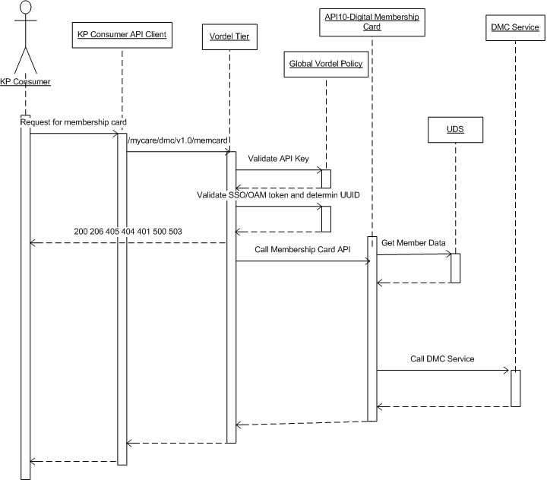

Limitations:

1. Only 10 relationshipid will be passed in header X-RELATIONSHIP-ID.

Validations:
1. If primary member prefix is empty or null or we are unable to determine then Vordel API will send http status code 404 back to client.
2. If we cant find MRN for any relationshipid/proxy we will send INVALID_MRN value to DMC service.
3. Maximum 10 comma separated values are allowed under header X-RELATIONSHIP-ID and that response will include response for total 11 records ( 1(primary member) + 10 (proxy member ) ) unless error for few records for which error response will be included.
when more than 10 relaationship Ids are passed in header X-RELATIONSHIP-ID , then response will have error with description “More than 10 relationIds passed” See Sample Response #5

Http Status Codes:

Status Code | Meaning | Description
200 | Success
206 | Partial Response | Will come from DMC Service, Not all MRNs could fetched; one of the data sources is unavailable
401 | Unauthorized | ssosession or ObSSOCookie is not valid
404 | Resource not found | May come from DMC Service or Vordel API or when vordel is not able to find prefix for primary member
405 | Method not supported | Vordel API support only HTTP GET for this API, any other method like POST, PUT will result in 405 error.
500 | Internal server error
503 | Referenced Service may not be available | For e.g. UDS or Auth service Down
412 | Request can not be served or invalid | For, More than 10 relationship ids are passed

